# Objective

PSoC 4 BLE and PRoC BLE devices have 512 bytes of user configurable supervisory flash (SFlash) that is retained across normal programming cycle. This example project demonstrates how to write and read to this user SFlash locations from firmware.

|  |
| --- |
|  |

# Overview

PSoC 4 BLE and PRoC BLE devices have two types of non volatile memory:

1. User code flash used for storing the application program to be executed
2. Supervisory flash (SFlash) that is used for storing flash protection details, device trim settings, chip level protection etc.

In addition to features mentioned above, SFlash in PSoC 4 BLE and PRoC BLE devices also contains 4 user configurable rows that the application can use for storing Bluetooth device address, application specific data or manufacturing specific information (device serial number, application sensor calibration data etc.). This user configurable SFlash has the advantage that data stored in SFlash is not erased during normal device programming cycle or during a firmware upgrade using wired or over the air (OTA) bootloading.

The organization of user configurable SFlash in PSoC 4 BLE and PRoC BLE family of devices with 128KB user code flash size is as shown in .

Figure : PSoC 4 BLE Device SFlash Organization and Address



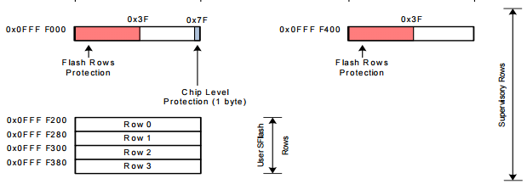

The user configurable SFlash can be accessed either through the SWD programming interface or from CPU using firmware. These SFlash locations are mapped directly to the CPU’s address space. Therefore, the user firmware or external programmer can read its content directly from the given row address. Writing to user configurable SFlash from the SWD interface is explained in detail in the BLE device family [programming specification](http://www.cypress.com/?docID=51803) and a C# utility is provided along with PSoC Programmer (located at ***C:\Program Files (x86)\Cypress\Programmer\Examples\Misc\PSoC4-BLE-SFLASH-Update\***) to update the user configurable SFlash during manufacturing.

This example project demonstrates how to update this user configurable SFlash location from user code so that application specific dynamic data could be stored and retrieved.

# Requirements

**Design Tool:** [PSoC Creator 3.1](http://www.cypress.com/PSoCCreator/) SP1 with built-in GCC 4.8.4

**Associated Devices:** All PSoC 4 BLE devices

**Required Hardware:** [CY8CKIT-042-BLE Bluetooth® Low Energy (BLE) Pioneer Kit](http://www.cypress.com/cy8ckit-042-ble/)

# Hardware Setup

The BLE Pioneer Kit has all the necessary hardware required for this example. shows the hardware setup for this example. USB connection is required for programming the BLE Pioneer Kit and also to display user messages on serial port terminal program on the host PC.

Figure : Kit Setup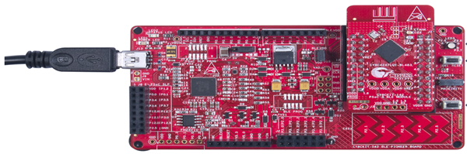

# PSoC Creator Schematic

Figure 3. PSoC Creator Schematic



**Firmware**

Figure . User SFlash Access Source Files

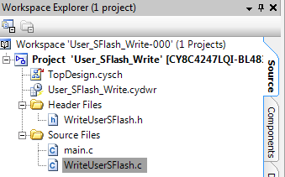

The important part of firmware in this example project is the “WriteUserSFlashRow” API located in WriteUserSFlash.c file. This API demonstrates how to write to user configurable SFlash location from CPU. The example project uses switch SW2 on BLE Pioneer Kit to trigger user configurable SFlash row update with a predefined data pattern and displays the content of the user configurable SFlash locations and other status messages on a UART terminal as shown in .

Figure . UART Console Output

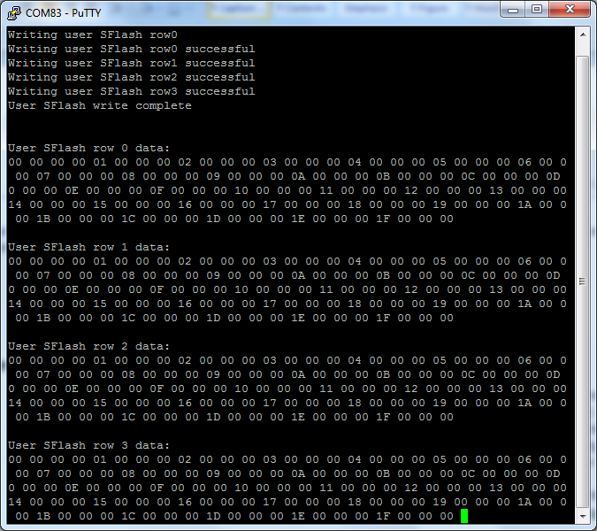





# Related Documents

lists all relevant application notes, code examples, knowledge base articles, device datasheets, and Component datasheets.

Table 1. Related Documents

| Document | Title | Comment |
| --- | --- | --- |
| [AN91267](http://www.cypress.com/go/AN91267/) | Getting Started with PSoC 4 BLE | Provides an introduction to PSoC 4 BLE device that integrates a Bluetooth Low Energy radio system along with programmable analog and digital resources. |